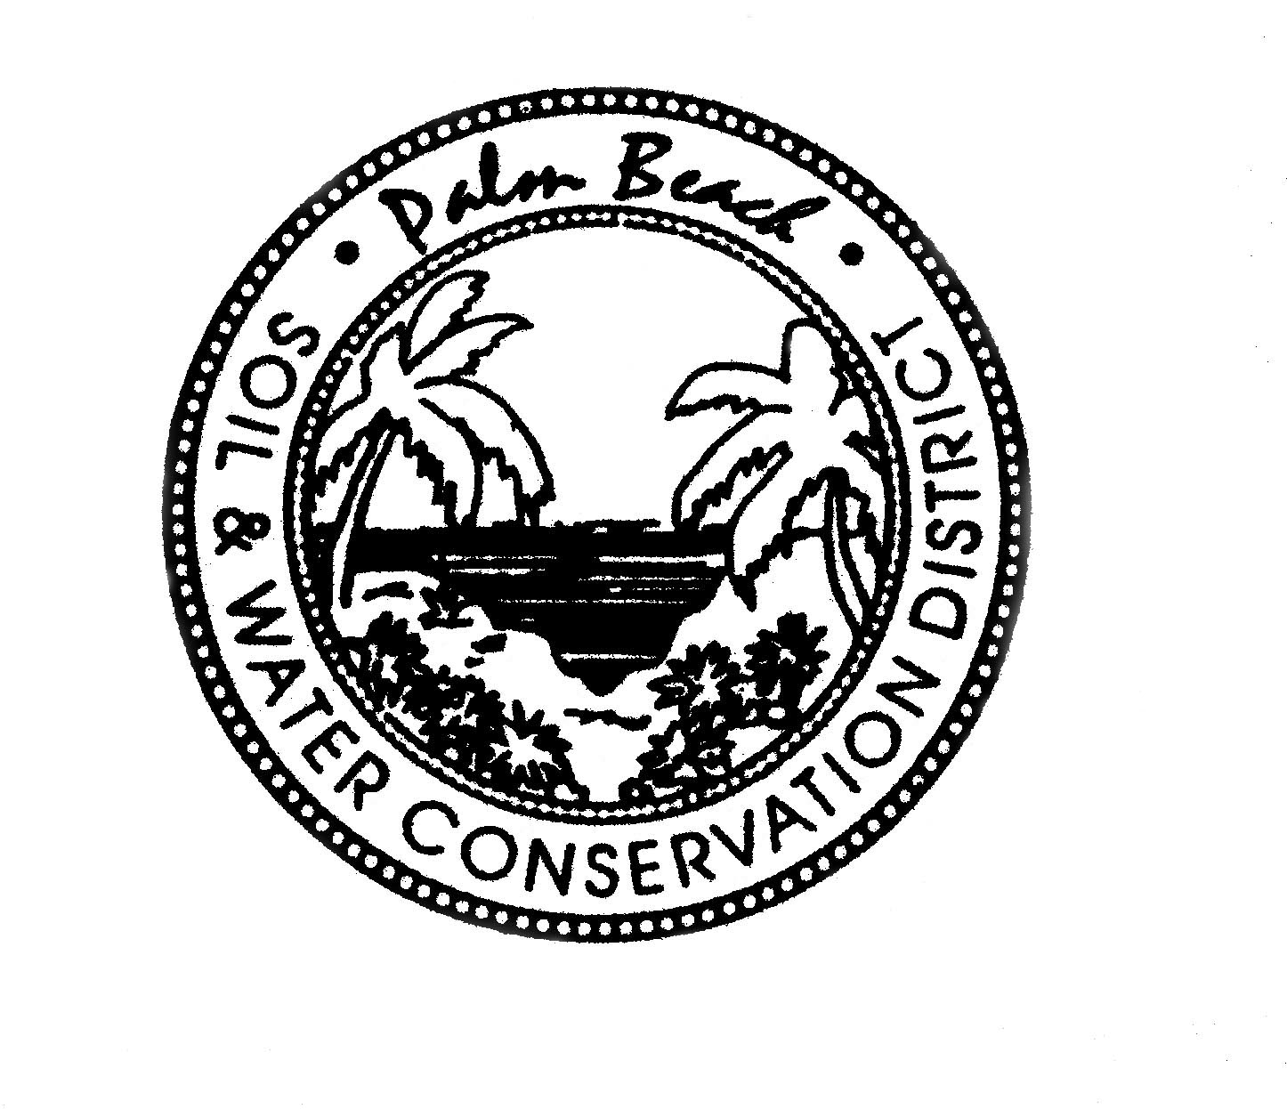

AGENDA

PALM BEACH SOIL & WATER CONSERVATION DISTRICT
BOARD OF GOVERNING SUPERVISORS MEETING

USDA Service Center 420 S. State Road 7, Royal Palm Beach, FL 33414
April 30, 2024 at 12:30 PM

Part of this meeting may be conducted as a video or teleconference in order to permit maximum participation of Board members (Section, 120.54(5)(b)2). The Board may take official action at this meeting on any item appearing on this agenda and on any item that is added to this agenda as a result of a change to the agenda approved by the presiding officer of the meeting pursuant to Section 120.525, Florida Statutes. The order of items appearing on the agenda is subject to change during the meeting and is at the discretion of the presiding officer.

1. CALL TO ORDER
A Roll Call
B Invocation
C Pledge of Allegiance

D Agenda Approval

2. SECRETARY’S REPORT
*Approval of the February Meeting Minutes

NEW BUSINESS
- * Draft Audit FY 22/23
- * Updated Budget

OLD BUSINESS

DISCUSSION ITEMS

PUBLIC COMMENTS

ADJOURNMENT
*DENOTES ACTION ITEM

